|  |
| --- |
| ChALMERS TEKNISKA HÖGSKOLA dAT255 |
| User manual |
| Appsolut Distribute |
| C:\Users\Michael\workspace\AppsolutDistribute\res\drawable-hdpi\ic_launcher.png |
| **Michael Henriksson, grupp25** |
| **2012-10-08** |

|  |
| --- |
| User manual for the Android-app AppsolutDistribute. |



Index

[User manual 2](#_Toc338688572)

[1. General 2](#_Toc338688573)

[1.1 Help 2](#_Toc338688574)

[1.2 About 2](#_Toc338688575)

[1.3 Settings 2](#_Toc338688576)

[2. Connect to server 2](#_Toc338688577)

[2.1 Create account 2](#_Toc338688578)

[\*\*\*2.11 Connect/create Google account\*\*\* 3](#_Toc338688579)

[2.2 Login 3](#_Toc338688580)

[2.3 Select server\* 3](#_Toc338688581)

[2.4 Manage account 3](#_Toc338688582)

[2.5 Exit 3](#_Toc338688583)

[3. Manage groups 3](#_Toc338688584)

[3.1 My groups 4](#_Toc338688585)

[3.2 Create groups 4](#_Toc338688586)

[3.3 Join groups/Answer group invites 4](#_Toc338688587)

[3.4 Group settings/options 4](#_Toc338688588)

[3.5 Delete group 4](#_Toc338688589)

[3.6 Help 4](#_Toc338688590)

# User manual

## 1. General

### 1.1 Help

Welcome to help! This section will guide you for a better app-experience with AppsolutDistribute. Use the index to find what you are looking for.

### 1.2 About

This app was created by a group of students at Chalmers University of technology as an assignment. The creators are: Mattias Isene, David Harald, Michael Henriksson, Anton Kostet and Stefan Arvidsson. We are using a free Apache 2.0 license.

### 1.3 Settings

By pressing the settings button a small popup will appear in the button of the screen. This is possible wherever you are in the app and from here you can change settings for your account.

## 2. Connect to server

### 2.1 Create account

To get started with your AppsoultDistribute app you have to create an account. This is done from the from the “Create Account” tab.

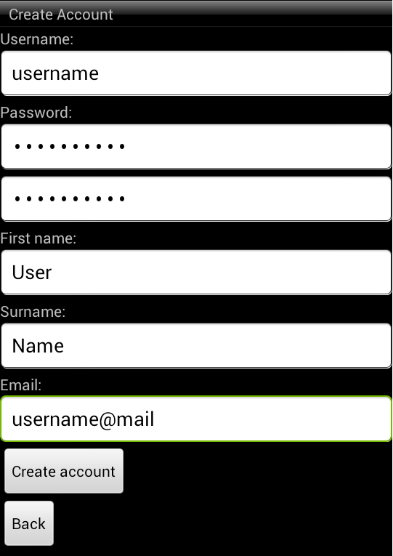

You need to fill in you user data, such as username, password, first name and surname. Make sure you remember your password! In this version there is no way to recover your password! The username needs to be unique. When you are done press create account, you are now ready to use AppsolutDistribute.

### \*\*\*2.11 Connect/create Google account\*\*\*

Not implemented in this version.

### 2.2 Login

Enter username and password then click ok.

### 2.3 Select server\*

\*User select/types specified server IP and server password. In the first version only one server will be available.

### 2.4 Manage account

Under the manage account tab you will find the tools to change password, user information and the option to end your account. Information such as first name, surname, email and more can be edited at any time using this button.

### 2.5 Exit

Pressing the Exit-button will show a popup with the text “do you really want to exit?”, by pressing ok you will terminate the app.

## 3. Manage groups

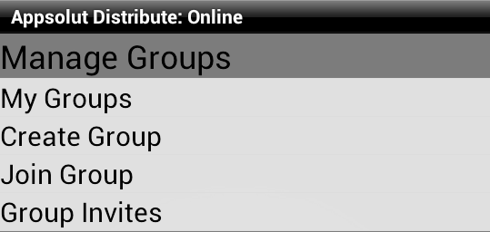 To access the manage group tab you need to be online and connected to the server. Under the manage groups tab you can change group name, password, add/remove users and more for the groups you have created or are moderator for.

### 3.1 My groups

My groups are the list of the user’s active and archived groups.

### 3.2 Create groups

To create a new group on the server you have to choose name, activities and invite members.

### 3.3 Join groups/Answer group invites

See a list of active invites.

### 3.4 Group settings/options

Change group settings, only available for admin or moderator.

If the user is admin or moderator in a group he can change settings for the group. Admin/moderator can perform changes such as change name and activities but has also the possibility to invite or kick users from the group. This is possible from the group settings tab. All changes must be confirmed with the group password.

### 3.5 Delete group

Show an option to delete group. User type password and press confirm button. Be aware, deleted group cannot be restored.

### 3.6 Help

The help under manage groups leads you to this user manual. It can be useful when you need help to manage your group, leave a group or change settings.